Emergency Vehicle Routing System [A*]
Project Number:10
Name Group ID
محمد حسام احمد عبد الحميد g3 2401258027
محمد عصام محمد عبدالجواد g3 2401256213
محمد هانى محمد عبيد g3 2401259015
محمد احمد خميس احمد احمد g3 2401257603
عمر ياسر السيد الجوهري g3 2401252342
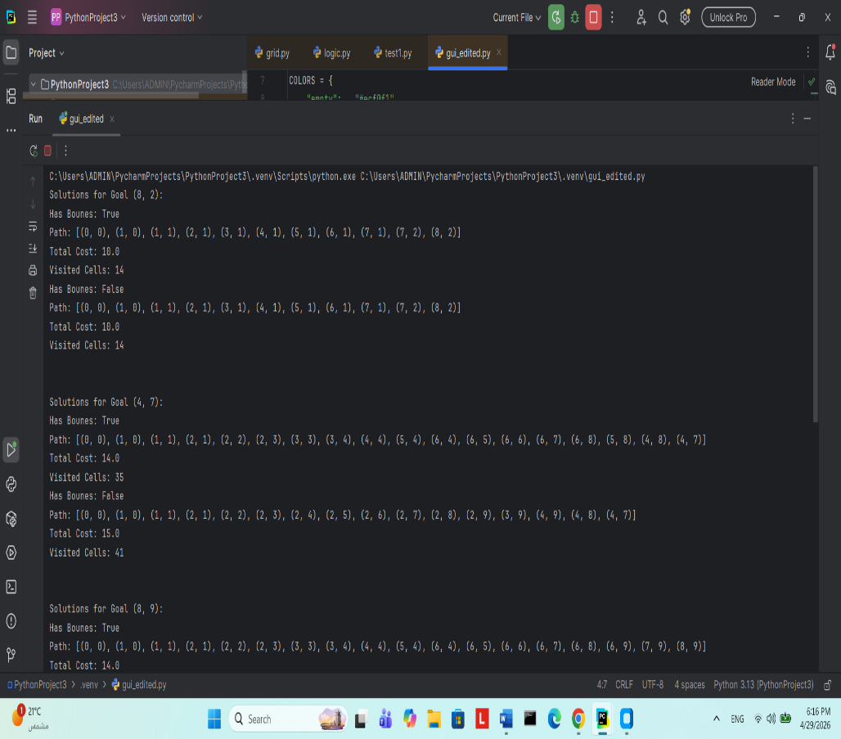
Project with logic Project with logic and gui
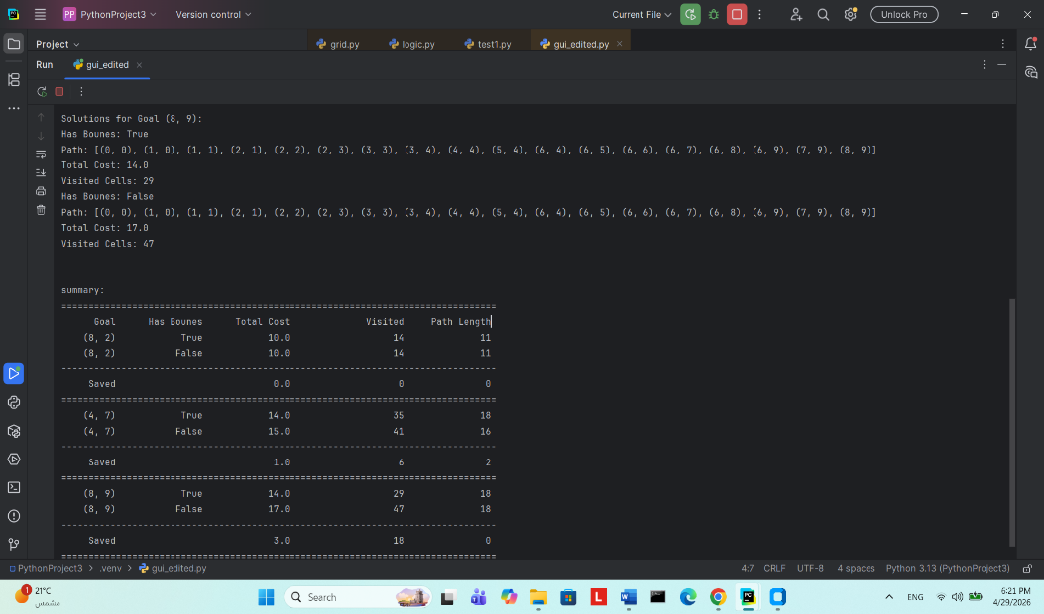
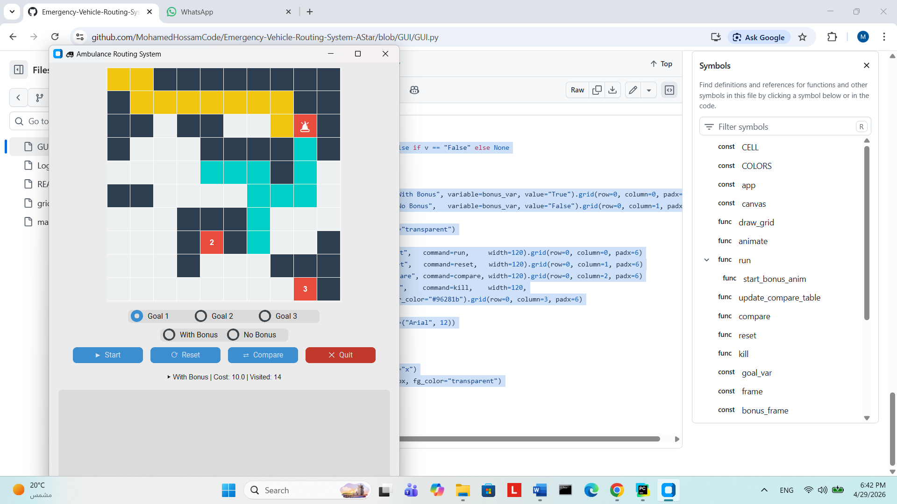
A* search method:
A* Depend on two factors: the g cost and heuristic code .The f(x)=g(x)+h(x).When a node is expanded, the algorithm calculate which potential path has the lowest f(x) and pop it out from the queue. Every path in the queue is sorted so that the first path is the path with lowest cost
____________________________________________________
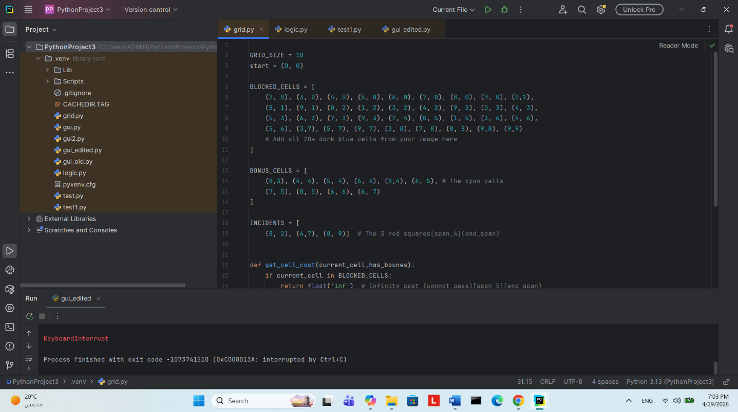
Grid part
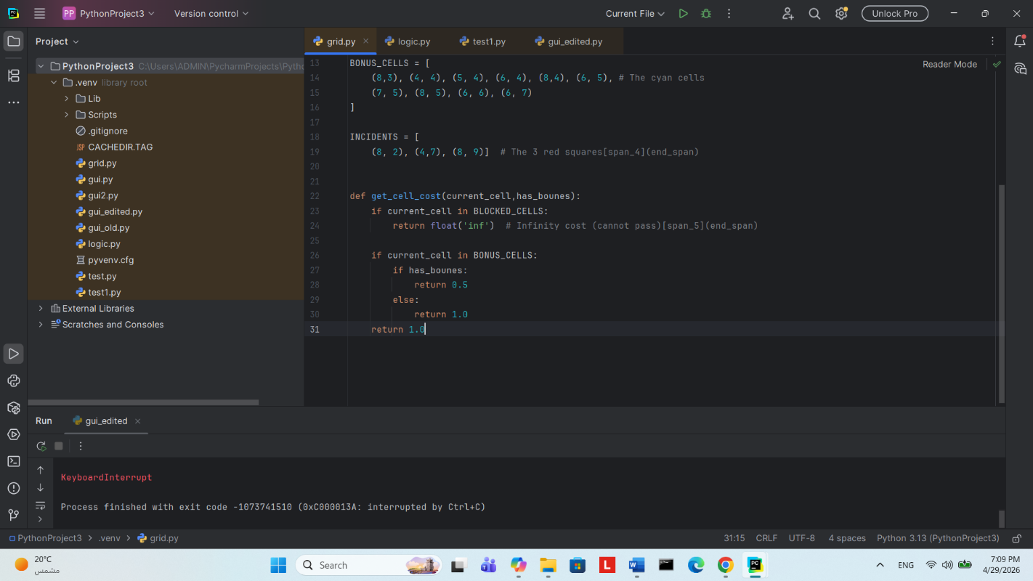
Grid size , blocked cell, incident cells were defined
The function get_cell_cost takes the current cell and whether it is bonus as parameters .The function return the gcost as 0.5 if the cell is bonus and has_bonus optimized to true. The gcost in blocked cells is return as infinity because A* will ignore them as they have the highest cost
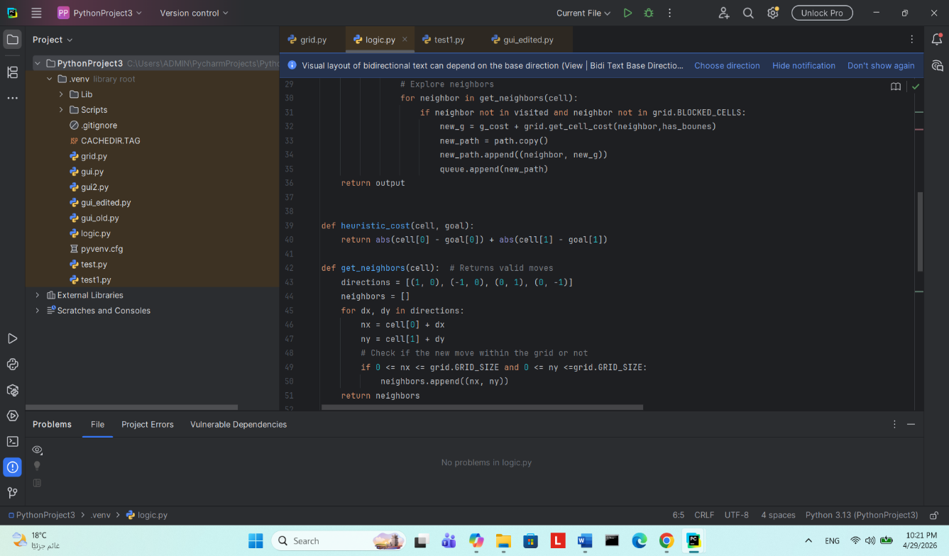
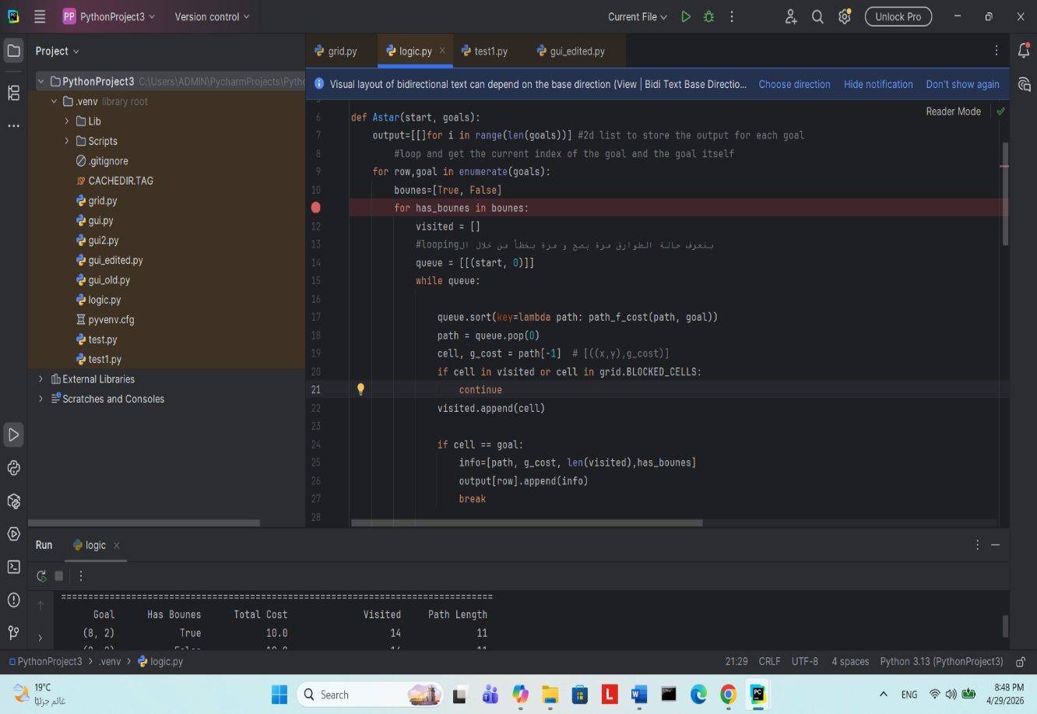
Logic part
The variable “output” is a list that store number of lists.The number depend on the number of goals in incidents.[7]
The for loop iterates through variable row(each index) and goal(each goal in the list).[9]
The next for loop iterate through the list bonuses to cover the 2 bonus cases.[10,11]
Variable queue is initialized with start cell and 0 which is the g cost.[14]
The while loop checks if the queue is empty or not[15]
Queue is sorted so that the least costed path is in the first[17]
The first path in queue is popped and stored in variable called path.[18]
If cell was previously visited or is blocked the above instructions are skipped;otherwise, the cell is appended into visited and the following codes are completed.[20,21,22]
This if statement check whether the current cell is the intended goal or not.If the goal reached, needed information(path, gcost,etc) is appended to a list,and the while loop is breaked[24,24,26,27]

This for loop iterate throught the neighbors of each cell[30]. Cell check[31]. The gcost of the neighbors is calculated by adding current cell’s g cost and the gcost of the neighbor cell[32].Through the loop, each neighbor is appended to the variable new_path, which will be appended to queue[33,34,35].The function heuristic cost calculate the Manhattan distance of every cell.The function neighbor get the neighbor cells, but how?.The are 4 possible directions to move move(up, down,left,and right).The for loop iterates through directions.Inside the loop, the x- coordinate and y-coordinate of the current cell is add to those of directions.However, at some points in the grid, changing direction may excceds the grid limit.Thats why we have to check whether the new x and y-coordinate is between 0 and 10.If the condition satisfies, the x y is appended to neighbors[42 to 51].

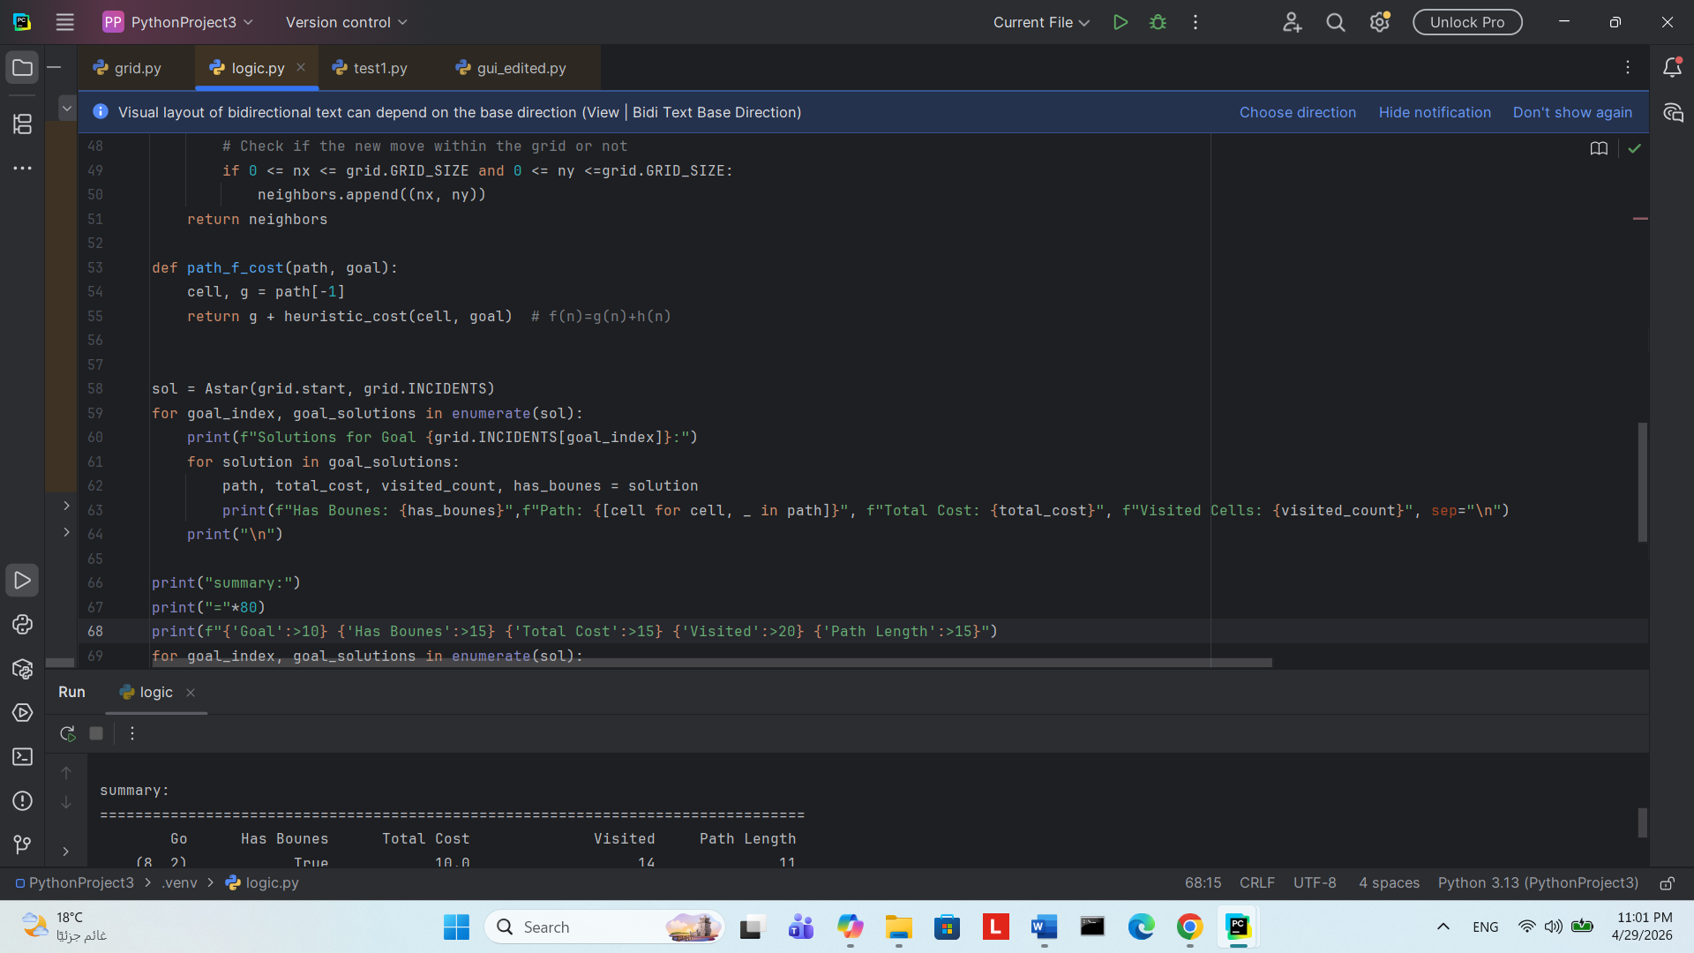
The final cost is calculated by adding g cost to heuristic cost. Then the result is returned[53 to 55].
The variable sol store list that contain list of all goal solutions.Each goal solutions contain bonus and nonbonus lists.[58]
The for loop loop through the goal index and goal_solution,which is contain the goal with bonus and without bonus[59]
The next for loop print all information in goal_solutions which refer to output list[line 7] in the code.[61 to 64]

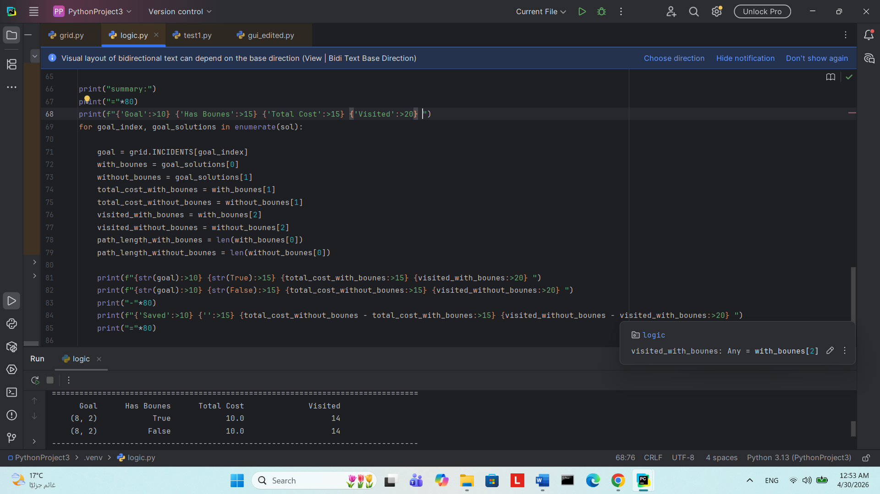
The summary includes information about Bonus,Total cost of the path, and the number of visted nodes(expressed in code as len(index).[66 to 68]
The for loop iterates through index(done by enumerate) and the goal solutions.
Each goal solution contains two lists: one with bonus and one without bonus.The two lists are accessed by 0 and 1 respectively.(look at line 10 to imagine the situation).Total cost is accessed by index 1 in with and without bonus lists.look at line 25;the total cost is located in the 1st index.The same concept applies to other variables[71 to 79]
To find cost saved, we subtract cost with bonus from cost without bonus.The same concept covers the number of visited nodes[84]

